**Water Issues, Homelessness, and Economic Development in the City of Albuquerque**

Huang (Albie)Hsiang-Wen

Indy Mitchell

Ivan Robles Ingram

Hannah Montoya

Jacob San Nicolas

**University of New Mexico**

**CRP-165-001 Social Issues in Urban and Regional Development**

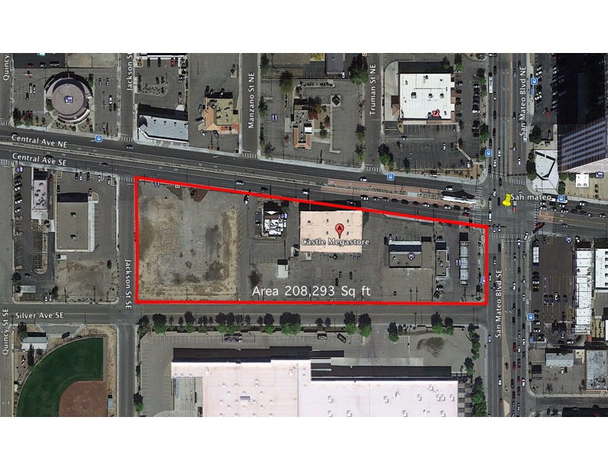

Project Location: Project Location: 5110 Central Ave SE (Land Value $1,494,291)

**Introduction**

Albuquerque is a potential urban city located in the desert area of Southwest America. The city is intersected by two major highways, I-25 and I-40, which makes the city easier to navigate. The city provides many opportunities for investors to participate and develop in plenty of fields such as business, technology, nuclear energy, research, medical science, art & film, architecture, city planning, etc. Its diverse culture and artistic atmosphere attracts people to experience the city with an affordable and unique living experience.

In contrast, residents in Albuquerque are also experiencing the threats of limited natural resources and the safety issues of crime rate and drug abuse all over the city. With the current situation, how can we design our city to make it healthier? How can we impact the city through sustainable and renewable urban planning?

**Project Planning and Solution**

Our team identifies some of the current major issues in Albuquerque, and specifically targets water usage and homelessness to improve the city’s economic development. In this project, we used the bond money to reconstruct local stores into homeless shelters, build a mixed-use community water contribution center, and turn a parking lot into green space. The planning site is located at the intersection of Central and San Mateo. We calculated the cost and designed a 3D physical site model for this project based on the bond budgets. Our goal is to benefit the community members through physical planning, create a higher quality environment and a safer neighborhood. In the project analysis below, some possible solutions and suggestions are provided in hopes of making Albuquerque a safer and better place to live.

**Physical Planning Design Theory:**

The project is located at the intersection of Central and San Mateo. It consists of the rehabilitation of an existing building into two homeless shelters, a Water Contribution Center, and green spaces with several solar panels. The homeless shelters are for low-income residents and homelessness in this community. The two roof additions to the existing building are designed to collect water and transfer it into the attached cistern as well as transform sunlight in to solar energy. The solar panels are located along the sidewalks to provide shade and shelter from the elements as well as the charging devices. There are also windmills with a height of 60 feet for extra energy collection to provide green energy. The design is to provide insight for people to know how the energy is created, stored and used.

Each homeless shelter has a terrace for open air access that overlooks the park. This will help people adjust to more stable living conditions as well as provide a temporary address. The homeless shelters provide housing, mental/physical health and self-hygiene facilities. The water contribution center is not only for collecting water but also to provide a community center that includes an administration office, a cafeteria, a medical facility, and an art gallery. The water contribution center also offers a program that is accessible to the homeless to acquire essential job skills. The green space has several parks meant to be a social space open to the entire neighborhood. It also includes parking lots for the off-street parking. This project will help improve the homeless issue on Central and provide a better community lifestyle.

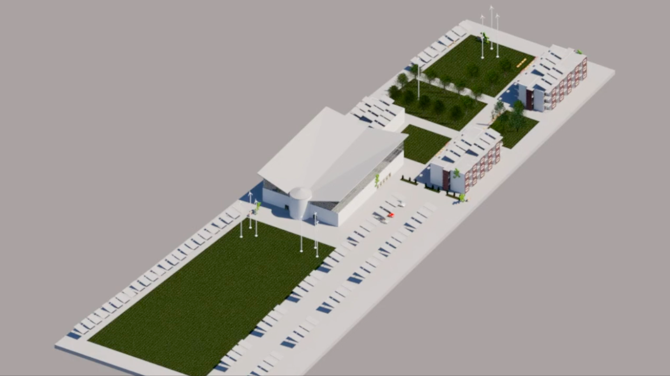

Site Redesign Image (Revit model)

**SECTION ONE: HOMELESSNESS**

**Issue:**

In 2017, there was a survey conducted in Albuquerque counting 1,318 homeless men, women and children and this number went up just two years later to 1,524 people. Granted, it is very difficult to count every homeless person for this data because they are always on the move, finding warmth at night, and perhaps taking shelter from the elements. Regardless, the number has increased and many cities are facing a similar homeless crisis. Here are some proposed solutions to overcome this issue.

**Solution:**

After researching homelessness in other countries, it was found that the Japanese government respects their homeless people and hold space for them. The Japanese government allows the homeless to set up camp where they feel comfortable. No one is allowed to touch these structures, not even law enforcement. The Japanese government also keeps account of the homeless by completing surveys every year.

Denmark’s government has an available welfare system that is easily accessed. Denmark reports that many of the homeless have either a mental illness or have drug addiction. In order to help the mentally ill and drug addicts, Denmark has implemented a system where healthcare is easily accessible. In Switzerland, the government has very good social services in place so that it is accessible as well. They also have very good education systems that are able to educate people without having to put them into debt.

To implement some of these ideas into Albuquerque it would start with adopting a few programs that are already in place in Albuquerque such as the Emergency Shelter Grants Program. This program gives grants to states and organizations in order to help build emergency/transition shelters that provide essential social services and prevents homelessness. For this service, it will cost $193,783. The next step was to adopt the Continuum of Care Program. This program provides funding to create permanent/transitional housing & supportive services. All of these services will cost $163,211. The next thing that would be implemented would be Health and Social Service Center Kitchens. With this planning, designing, constructing, equipping, furnishing, and providing security as well as technology upgrades and otherwise improving to Health and Social Service Center kitchens. This project will cost $900,000. There would be $1,500,000 set aside for renovations, repairs, security and technology improvements. In order to make sure that people from the community become involved with the homeless shelter the people working at this facility would promote people to volunteer at this place, as an incentive to volunteer advertising volunteering as a resume builder. Fundraisers will be held as well as food drives.

***Bond N0 4. Senior, Family, Community Center, Homeless, and Community Enhancement Bonds***

* Homeless Facility (14,000,000)
* Renovation, Repair, Security and Technology Improvements: Existing FCSD Facilities (1,500,0000)
* Health and Social Service Center Kitchens (900,000)
* District 1 Community Center (500,000)
* Senior, Family, Community Center, Homeless, and Community Enhancement Projects Council District 3 (300,000)
* Public Art (215,000)

+++ _____________________________________________

**TOTAL Funding Used for Homelessness: $ 17,415,000** (Out of $21,705,000 Available)

To reference the available Bond that the City of Albuquerque is giving towards this project can be found here:

**Community Center Bond No.2 :**

[**https://www.cabq.gov/municipaldevelopment/documents/2-senior-family-community-center-homeless-and-community-enhancement-bonds.pdf**](https://www.cabq.gov/municipaldevelopment/documents/2-senior-family-community-center-homeless-and-community-enhancement-bonds.pdf)

**SECTION TWO: WATER USAGE and COLLECTION**

**Issue:** water waste and limited access to water

**Reason that caused the problem:** as a culture we are taught to naturally waste water when brushing our teeth, washing hands, showering, etc.

**Solution:** Implementing rainwater harvesting and grey water systems into urban design as a way to recycle water and reduce the amount of grid water consumed and wasted.

**Plumbing**

Freshwater is a precious resource that most of humanity continues to take for granted. For example, the vast majority will let the faucet run on high while they brush their teeth and older sinks have a flow rate of at least two gallons per minute. People let the shower pour into the drain while stepping in front of the flow to shampoo, shave or body wash. Older shower heads can spew 2-5 gallons per minute. The worst is toilet flushing.

The water that fills a toilet is the same fresh tap water that flows out of sinks in the United States. There are children in other countries that do not have access to potable water, yet U.S. citizens excrement in it. According to the Alliance of Water Efficiency, it is estimated that a person flushes five times per day on average. “If your toilet was made before 1982, it could use as much as 5 to 7 gallons of water per flush. From 1982 to 1993, many toilets were made to use 3.5 gallons per flush. Federal guidelines require newer toilets to use less water, with 1.6 gallons being the maximum legal amount per flush” says Christopher John of Hunker Home Design (Perlman). Toilet flushing accounts for 30%-50% of a person’s total daily water usage. If you consider a large establishment like the University of New Mexico with a student body of 24,000 people, the gallons of water flushed per day is immeasurable- and this is just one school, in one city, in one state.

According to the United States Geological Survey (USGS), 80-100 gallons of freshwater are used per person, per day (John,2018). For a family of four, this is about 116,800 - 146,000 gallons of water used per year! The numbers drastically increase when lawn and garden irrigation is added. When a family relies solely on rain catchment for their daily water needs, the usage becomes far below these averages. After the initial investment for a cistern and filtration system, there are no more water bills. Catching water from the sky is free! Plus, harvesting rain does not continue to deduct from this planet’s already limited resource of freshwater.

**Roofing**

New Mexico is one of the driest states in the country so every raindrop is vital. As the rain falls, it lands on the roof which needs to have the highest run-off rate possible. Metal roofing, versus conventional asphalt shingles, is ideal. Asphalt will eventually leach chemicals and tiny particles of tar into catchment water; metal roofing does not do this. The roof pitch is also an important factor in rain catchment. The pitch is the angle the roof is positioned upward from horizontal or flat. Poorly constructed roofs have a zero-degree pitch which allows water to remain puddled and stagnant on its surface. Too steep of a pitch though, will cause rain to clear the cistern because it is moving too fast in heavier storms.

**Rain Harvesting**

The rainwater flows into a catchment system which is designed to filter out larger debris then hold it for future use in a large storage container called a cistern. Cisterns are large, often plastic, storage containers for rainwater catchment. Over time, plastic can degrade and leach chemicals into the water if left to full sun exposure. It is advised to cover cisterns from the harmful UV rays with an impermeable layer or completely bury them. We propose keeping the cisterns above ground. By keeping them in plain view, they can be used as an educational tool about rainwater harvesting and the benefits it creates. If it is buried, the common thought process becomes “out of sight, out of mind.” We tend to not understand what we cannot see.

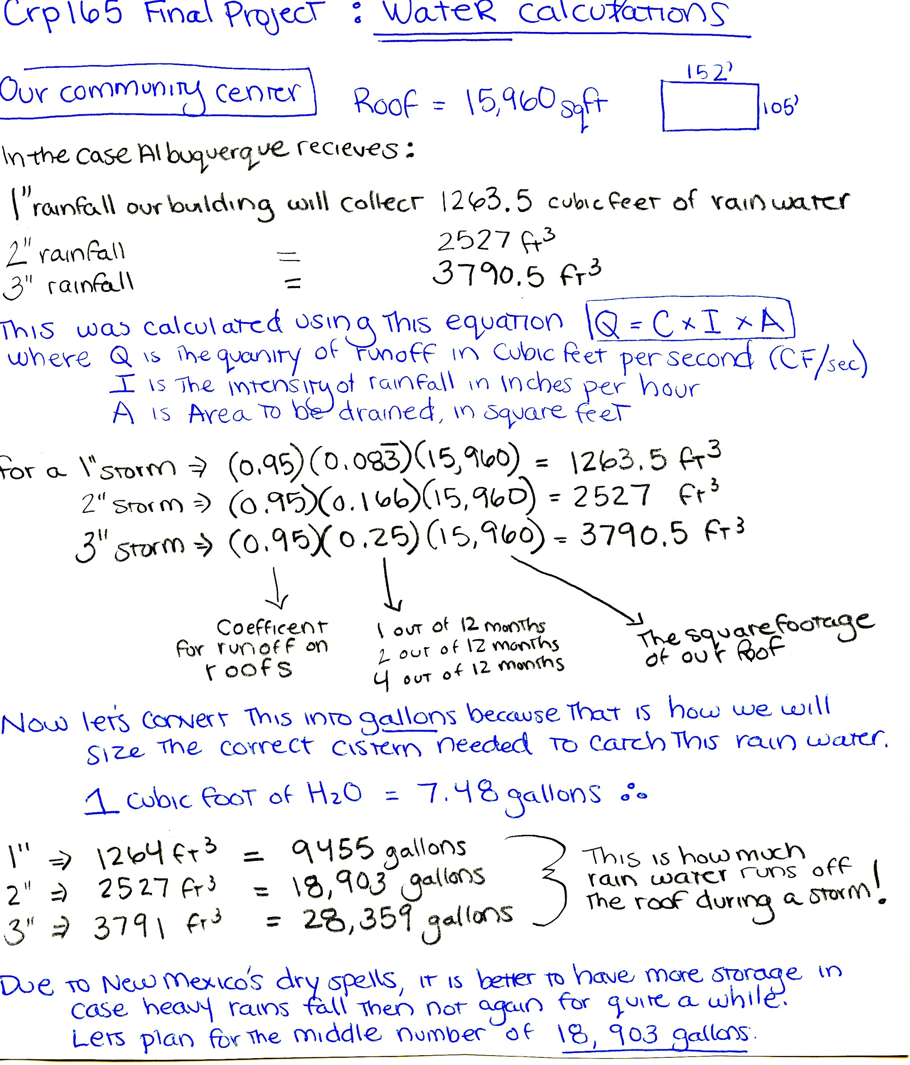



**Apartment Building Roofs:**

There are two apartment buildings in this design. Totalling 4224ft 2  roof area and contains 30 units each.

For a 1” rainstorm = 0.95 x 0.083 x 4224 x 2 (# of buildings) = 668.8 cubic feet of rain (ft 3)

Convert this into gallons: 1ft 3 = 7.48 U.S. liquid gallons:

668.8 x 7.48 = **5503 gallons** (rounded to nearest whole number)

The usual rainstorm ABQ gives only 1 inch of rainfall but this still creates 5,003 gallons harvested on these rooftops! This water can be used in many different ways but one can think of it as 5003 gallons harvested divided by 60 apartment units = 83.3 gallons each unit can use. By catching rainwater, you are saving gallons of free water from going down the drain. This is an example what only two small apartment buildings can harvest. As Northern New Mexico does experience long dry spells, it is better to round up in size to accommodate for these inevitable periods.

For physical planning purposes, the square footage a 10,000 gallons cistern will take up 109 square feet.

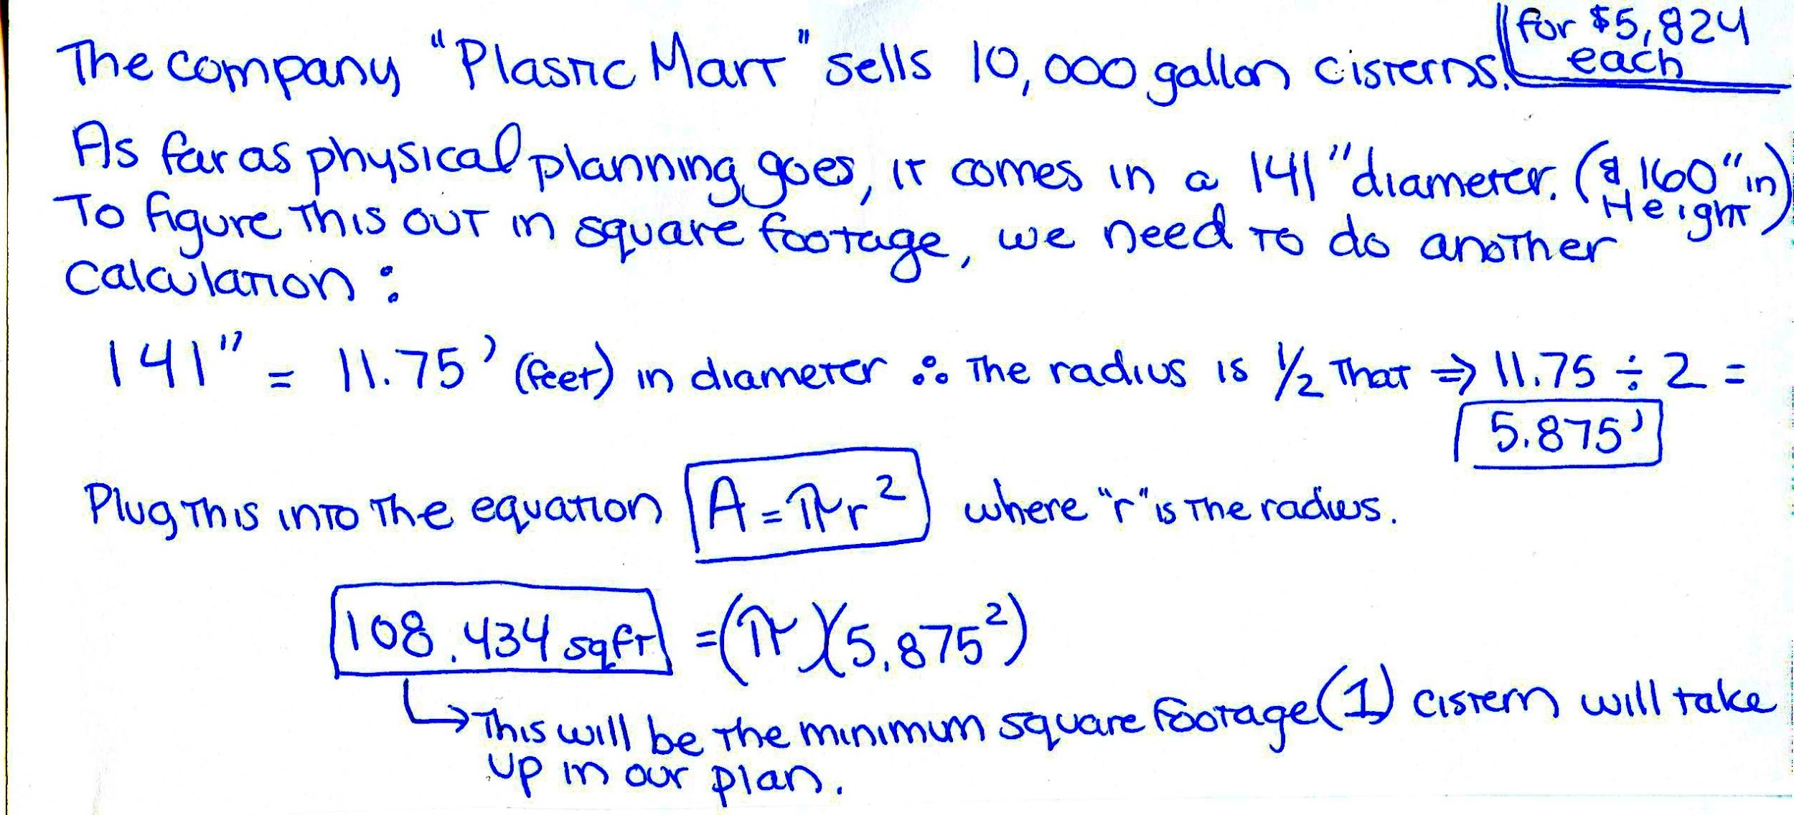

**SECTION THREE: ENERGY CONSERVATION**

**Solar Power**

Electricity in a home is often taken for granted just like water. Some people keep lights on when not in use, play videogames on large flat screens for hours, or use high-wattage appliances regularly. When living off-grid, you must get all of your power from the sun or wind, which is as amazing as it is limiting. Just like rain catchment, you must be mindful of your consumption habits- which is a good thing.

The sun releases enough energy in one hour to power the entire planet for a year. However, today, only one half of one percent of this free solar energy is being utilized by the United States (Vanorio, 2019). Why is this first-world country not harnessing this unlimited and free power?

For a quick solar science lesson, the sun emits an innumerable amount of photons per second. When these photons enter the Earth’s atmosphere and contact a photovoltaic (PV) cell, electrons are released. Attached to the PV cell are positive and negative conductors on each side which guide the electrons to create an electrical current (SunPower, 2019).Many PV cells are organized in a grid pattern to form a solar panel; many panels construct a module; and many modules wired together make a solar array.

“In 2018, the average annual electricity consumption for a U.S. residential utility customer was 10,972 kilowatt hours (kWh), an average of about 914 kWh per month (per home),” the US Energy Information Administration (EIA) states. Energy is measured by multiplying power by time (E= Pt) and power is measured in Watts. A kilowatt-hour is 1000 Watts of energy that are working for one hour. One becomes intrinsically aware of the amount of energy they are receiving and consuming when they are depending on solar energy to power their needs.

We propose the addition of 108 solar panels that will double as shade structures for guests to find refuge under and help offset our power consumption on site. Each panel is 10’ x 15’ which is 150 square feet. The company SunPower is highly recommended for their efficient solar panels and a rough calculation has been made from their best model.

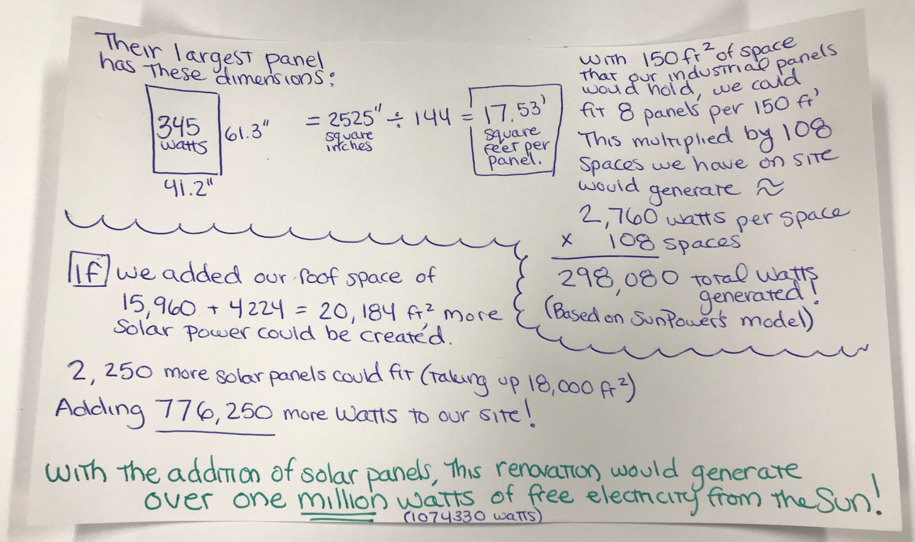

**Bond No. 4 Energy and Water Conservation**

* Roof Repair / Replacement for City Facilities ($1,000,000)
* City Building Construction, Improvements, and Rehabilitation ($1,000,000)
* Electronic Plan Review (ePlan): $115,000
* Training New Staff on Business Technology: $420,000
* Network Equipment Upgrade: $500,000
* 3% for Energy Conservation: $3,855,000
* 1% for Public Art: $105,000

+++_________________________________

**Bond Money Used for Water : $6,995,000** (Out of $10,420,000 Available)

To reference the available Bond that the City of Albuquerque is supplying towards this project can be found here:

**Water and Energy Conservation Bond No.4 :**

[**https://www.cabq.gov/municipaldevelopment/documents/4-energy-and-water-conservation-public-facilities-and-system-modernization-bonds.pdf**](https://www.cabq.gov/municipaldevelopment/documents/4-energy-and-water-conservation-public-facilities-and-system-modernization-bonds.pdf)

**SECTION FOUR: CITY ECONOMIC DEVELOPMENT**

**Issues:**

1. Most of the community does not have the ability to expand the reach of their local products nationally
2. Drug abuse and poor health care problems create a vicious cycle
3. Lack of accessible information about city programs/resources

**Drug Issue**

One of the biggest reasons that cause the homelessness issue in Albuquerque is the drug abuse issue. The major side effects of opioids are tolerance, physical dependence, depression, sleepiness, and poor wound healing. New Mexico Department Of Health describes “Most opioids are narcotic medications used to treat pain. Opioid medications work by binding to specific opioid receptors in the brain, spinal cord, and gastrointestinal tract. In doing so, they minimize the body’s perception of pain.” The website also mentions, “Individuals who have been incarcerated or individuals returning home from substance abuse treatment are at especially high risk for overdose if opioids are restarted.” So, It was highly addicting and risky to a teenager or feeble-minded person, especially in the low-income area. Unfortunately, It is very easy to get opioids from the doctor in the United States. People taking drugs start because it relieves physical or mental pain. People they start to enter into an addictive cycle due to opioid abuse. After the people physically become dependent on opioids, they will try to get higher-dose drugs from the street. Because if they stop taking drugs they will go into withdrawal. When people could not financially afford the cost of the drug, they start to find ways to get money from anywhere they can to buy the drugs. That directly increases the crime rate in the community. This is why the government needs to limit the users of prescription opioids. In addition, according to the New Mexico Department of Health, in 2017, there were 491 deaths due to drug overdose in the State of New Mexico. Two of three drug overdose deaths in New Mexico in 2017 involved an opioid (prescription opioids, heroin, or fentanyl). Also, the methamphetamine death rate in NM more than doubled from 2013-2017

Solution: Community and local schools should inform residents the dangers of opioids to solve the problem from the root.

**Create opportunity for employment**

It is important to collaborate and develop partnerships between school, community, and local businesses to create a job chain for students and supply local businesses with a standard training employee. The website *city of Albuquerque* mentions that “The Albuquerque metro area has a pipeline of more than 60,000 college students, with a labor force of nearly 450,000. It’s a young, affordable and smart workforce. In 2016, more than 3,700 software developers and programmers were working in New Mexico.” We have capable number of high education individuals as well as a capable workforce, so to combat the talent drain that Albuquerque is experiencing. We need to create more desirable employment opportunities the young, the city should make efforts to impede the talent drain by showing the city potential.

The article *Why Higher Ed and Business Need to Work Together* argue that “The speed of technological innovation and industry demands is moving faster than higher education’s ability to adapt.” If the local business could partner with local school, provide intern position for students to become involved in the programs. This could benefit students and increase the employment rate after graduation. Students will be better prepared and have a better skill base. The local businesses will have more options when they recruit employees. The article also mentions that 71% of the corporate recruiters prefer recruiting applicants with sufficient practical experience. That will lead more parents willing to support their kids to finish higher education, pushing the local economic.

**Tourism and Developing Local Cultural Features**

To achieve economic growth, it is important to develop and promote local business as well as the tourism industry internationally with government subsidization. The city should establish tourist attractions that are accessible by public transportation, especially from airport to University, Downtown, or Santa Fe. Communicating with the community is one of the most important steps before planners implement plans. The citizens need to understand the potential benefit and see the research so that they are more inclined to agree. I also think that the community member should have representatives involved in the planning process. One of the challenges is that the city of Albuquerque is lacking in communication.

The article *Community tourism planning: a self-Assessment instrument,* the authors cite information from Reid, Taylor and Mair saying, *“*Follow-up research into the impacts of the lack of involvement in planning suggests that missing this step often leads to the build-up of tension as developing the tourism product becomes dominant and avenues for resistance are narrowed.” The community should also increase information exposure to attract local people or tourists to participate in local events, city plans, and various activities. We can increase the bulletin board (either paper of electric board) in the public spaces, such as school, park, bus stop, community center for citizens so that will have multiple ways to approach useful information that came from community or city.

**REFERENCES:**

Albuquerque, NM. (n.d.). Retrieved from <https://www.hudexchange.info/grantees/albuquerque-nm/>.

Albuquerque, NM. (n.d.). Retrieved from <https://www.hudexchange.info/grantees/albuquerque-nm/?program=3>.

Albuquerque, NM. (n.d.). Retrieved from <https://www.hudexchange.info/grantees/albuquerque-nm/?program=5>.

City of Albuquerque. (n.d.). Retrieved December 5, 2019, from <https://www.cabq.gov/municipaldevelopment/documents/2-senior-family-community-center-homeless-and-community-enhancement-bonds.pdf>.

Community Profile. (n.d.). Retrieved December 4, 2019, from <https://www.cabq.gov/economicdevelopment/why-albuquerque>.

John, Christopher. “How Much Water Is Supposed to Be in a Toilet Tank?” *Hunker*, Hunker.com, 20 Aug. 2018,<https://www.hunker.com/13417565/how-much-water-is-supposed-to-be-in-a-toilet-tank>.

King, M. D. (2015, July 17). Why Higher Ed and Business Need to Work Together. Retrieved December 4, 2019, from<https://hbr.org/2015/07/why-higher-ed-and-business-need-to-work-together>.

Perlman, Howard, et al. “Per Capita Water Use: How Much Water Do You Use in Your Home?” *Per Capita Water Use: How Much Water Do You Use at Home? USGS Water Science School*, United States Geological Survey,<https://water.usgs.gov/edu/activity-percapita.php>.

Prescription Opioid Safety. (n.d.). Retrieved December 4, 2019, from<https://nmhealth.org/about/erd/ibeb/pos/>.

SunPower. “What Is Solar Energy and How Do Solar Panels Work?” *SunPower*, 26 June 2019,<https://us.sunpower.com/what-solar-energy-and-how-do-solar-panels-work>.

Richard Luecking, Ann Deschamps, Ruth Allison, Jacque Hyatt, and Christy Stuart. (2015). A Guide to Developing Collaborative School-Community-Business Partnerships.<http://www.parentcenterhub.org/wp-content/uploads/repo_items/ntact-scb-partnerships-guide.pdf>

Vanorio, Ame. “Every Drop Counts: Rainwater Harvesting 101.” *Fox Run Environmental Education Center*, Fox Run Environmental Education Center, 13 Apr. 2019,<https://www.foxrunenvironmentaleducationcenter.org/alternative-energy-blog/every-drop-counts-rainwater-harvesting-101>.

et al, K. (2005). Drug Overdose In New Mexico. <https://nmhealth.org/publication/view/marketing/2117/>